**Excel Assignment – 6**

1. **What are the various elements of the Excel interface? Describe how they're used.**

**Ans:** The various elements of the Excel interface are as follows:

|  |  |
| --- | --- |
| Ribbon Tabs | Ribbon Tab is a tab that organizes commands by topic |
| The Ribbon | Commands underneath the Tabs |
| Ribbon Groups | Grouping of related commands |
| Dialog Box Launcher | Opens a dialog box that includes additional commands |
| Quick Access Toolbar | One click accesses to any frequently used command |
| Name Box | Displays cell location and can be used to navigate to a cell location |
| Select All Button | Selects all the cells in a worksheet |
| Formula Bar | View, enter, or edit cell contents |
| Insert Function Button | Displays Insert Function dialog box |
| Scroll Bars | Used to navigate up, down, left & right |
| Zoom Slider | Zoom into an area of the worksheet |
| View Buttons | Switch between Normal, Page Layout and Page Break Preview views |
| Worksheet tabs | Tabs used to select individual worksheets |
| The Workspace | The area inside of the columns and rows used in Excel |

1. **Write down the various applications of Excel in the industry.**

**Ans:** The various applications of Excel in the industry are as follows:

* [Business Analysis](https://mallory.com.au/cm/ms-excel-uses-business-workplace/#1-business-analysis)
* [People Management](https://mallory.com.au/cm/ms-excel-uses-business-workplace/#2-people-management)
* [Managing Operations](https://mallory.com.au/cm/ms-excel-uses-business-workplace/#3-managing-operations)
* [Performance Reporting](https://mallory.com.au/cm/ms-excel-uses-business-workplace/#4-performance-reporting)
* [Office Administration](https://mallory.com.au/cm/ms-excel-uses-business-workplace/#5-office-administration)
* [Strategic Analysis](https://mallory.com.au/cm/ms-excel-uses-business-workplace/#6-strategic-analysis)
* [Project Management](https://mallory.com.au/cm/ms-excel-uses-business-workplace/#7-project-management)
* [Managing Programs](https://mallory.com.au/cm/ms-excel-uses-business-workplace/#8-managing-programs)
* [Contract Administration](https://mallory.com.au/cm/ms-excel-uses-business-workplace/#9-contract-administration)
* [Account Management](https://mallory.com.au/cm/ms-excel-uses-business-workplace/#10-account-management)

1. **On the ribbon, make a new tab. Add some different groups, insert commands in the groups and name them according to their commands added. Copy and paste the screenshot of the steps you followed.**

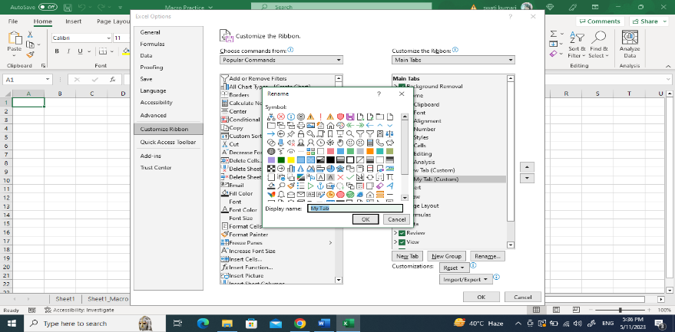

1. **Make a list of different shortcut keys that are only connected to formatting with their functions.**

**Ans:**  The list of different shortcut keys that are only connected to formatting with their functions are as follows:

1. Italicize text: Ctrl + I
2. Bold text: Ctrl + B
3. Underline text: Ctrl + U
4. Apply or remove strikethrough formatting: Ctrl + 5.
5. **What distinguishes Excel from other analytical tools?**

**Ans:** Excel provides different color shades, font types to format the spreadsheet and differentiate between rows and columns. It is good to present useful presenting information such as balance, tax profit etc.

1. **Create a table and add a custom header and footer to your table.**

**Ans:** Insert -> Table -> Select my table has header